Perl & Awk Scripting

Foss Lab

Submitted by

Abhishek Manoharan
Roll number 2
S3 CSE
1. Create a text file and answer the following queries :
a) Search for the pattern ‘apple’ in the file and display the number of occurences.

Script
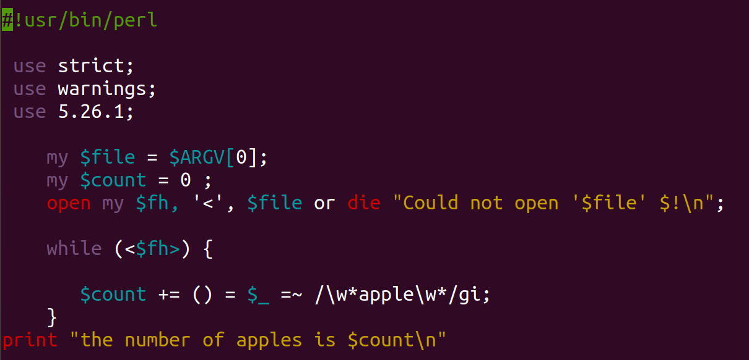
Output
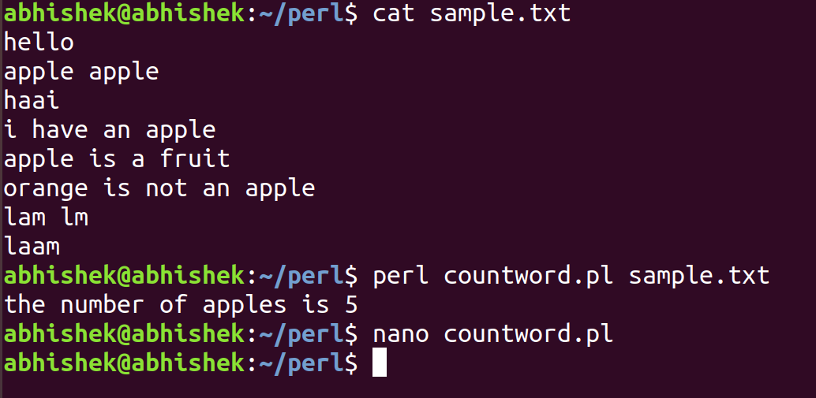
b) Count the number of words that ends with ‘e’

Script
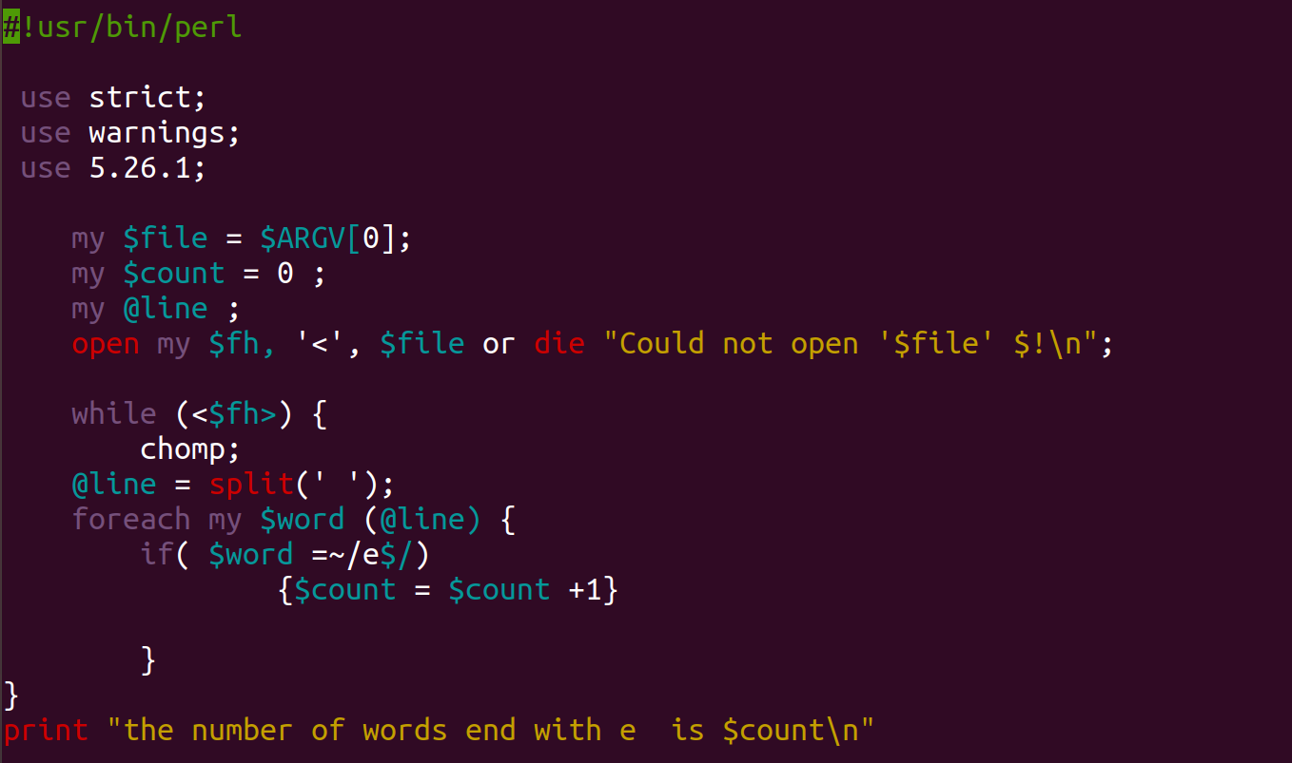

Output
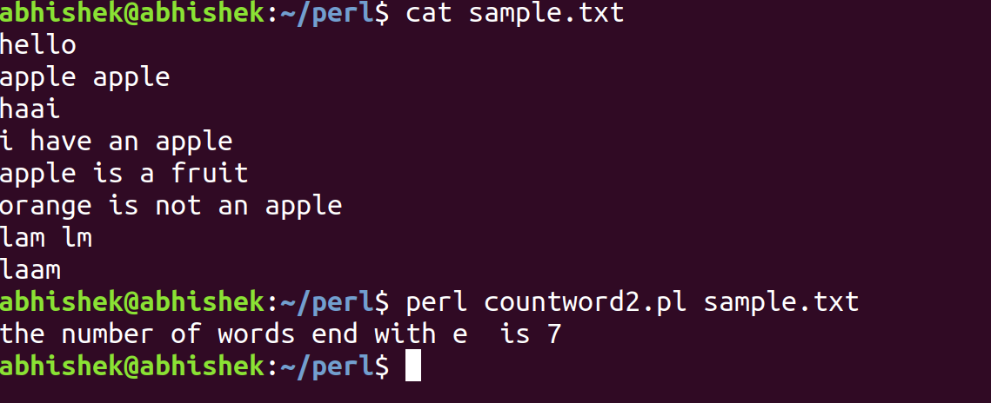
c) Count the number of words that starts with ‘ap’

Script
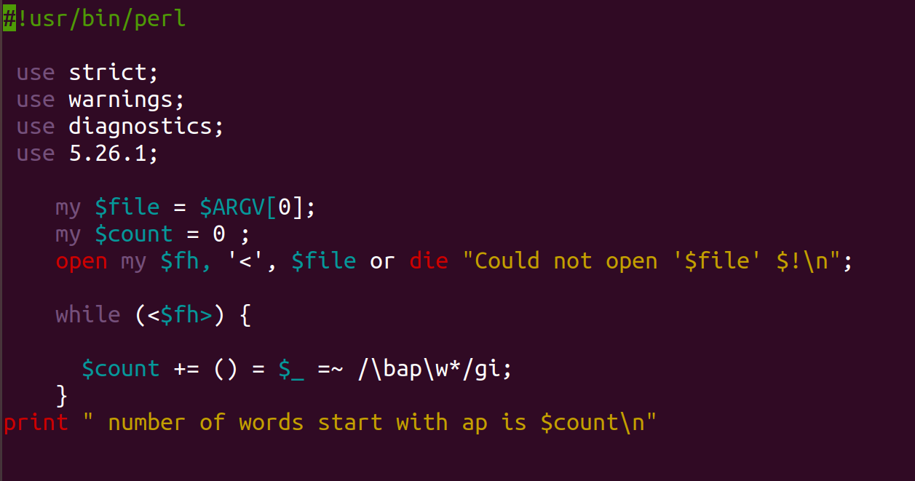

Output

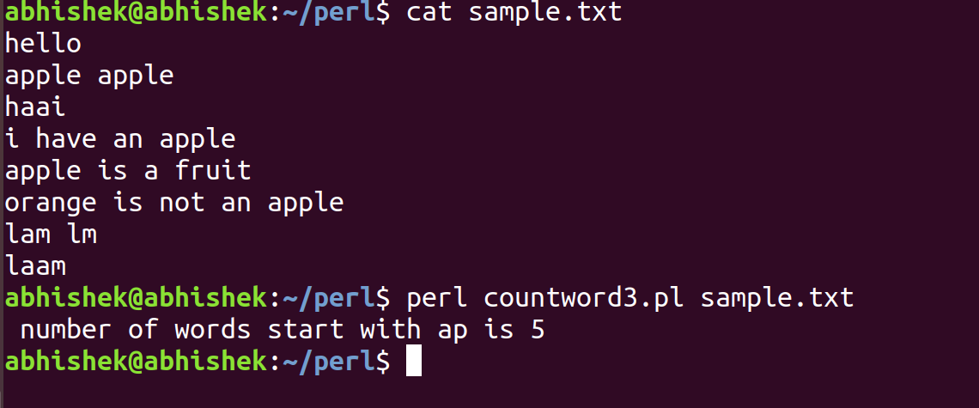
d) Search for words containing ‘a’ or ‘s’

Script

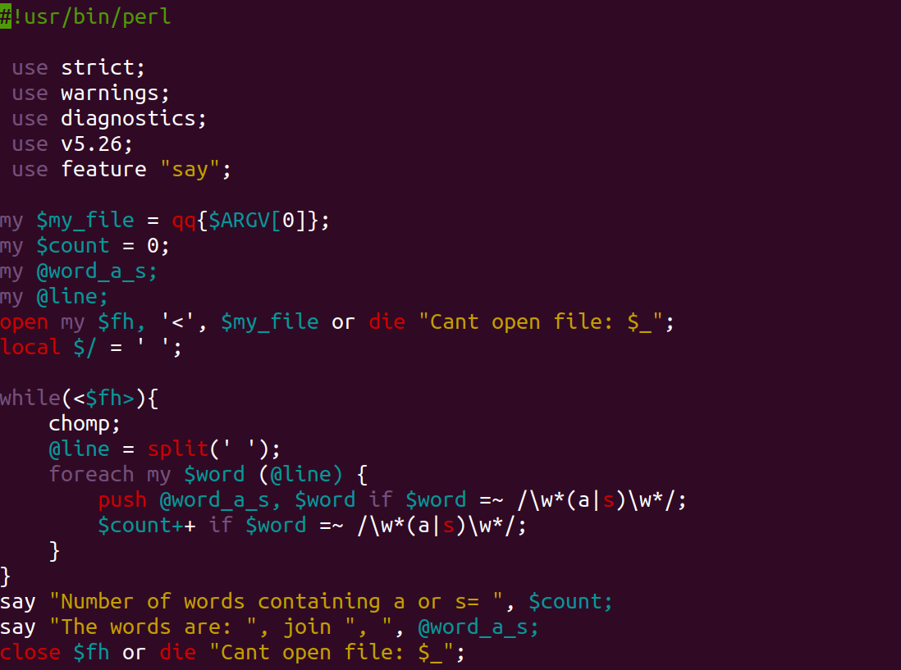
Output
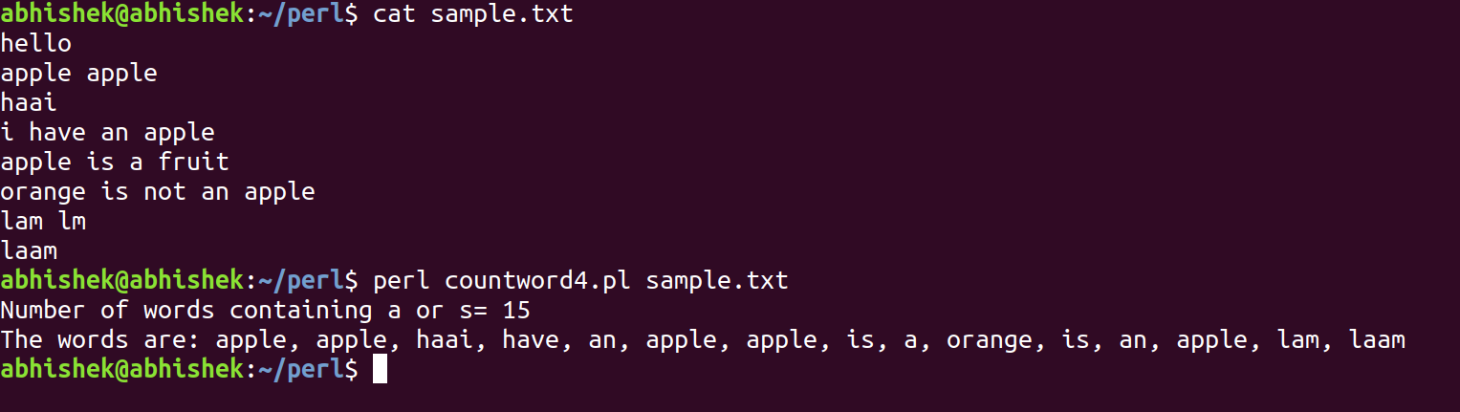

e) Search for words containing zero or more occurrence of ‘e’

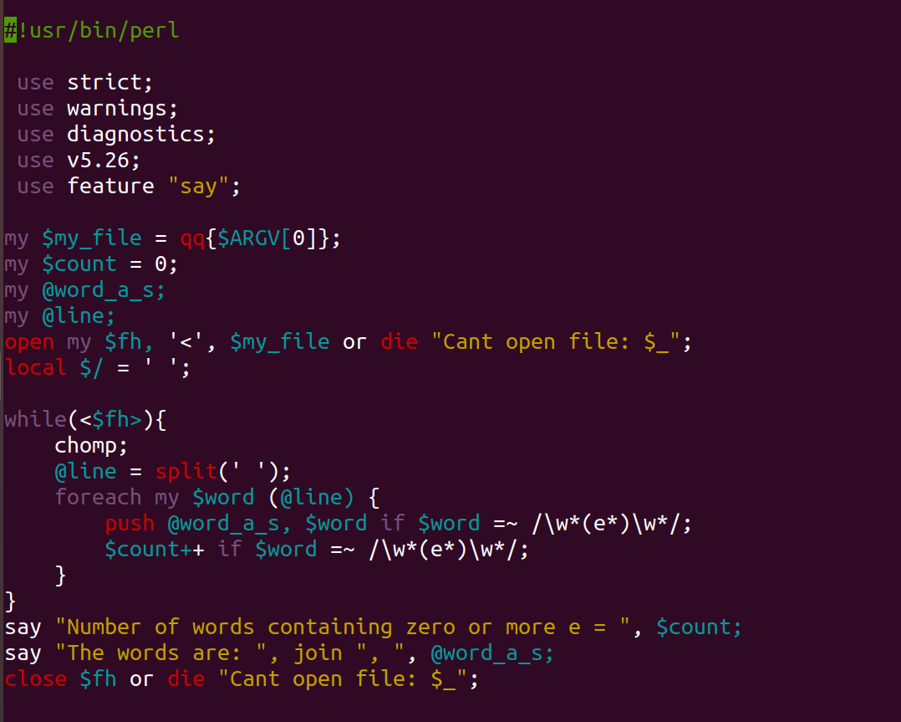
Script

Output

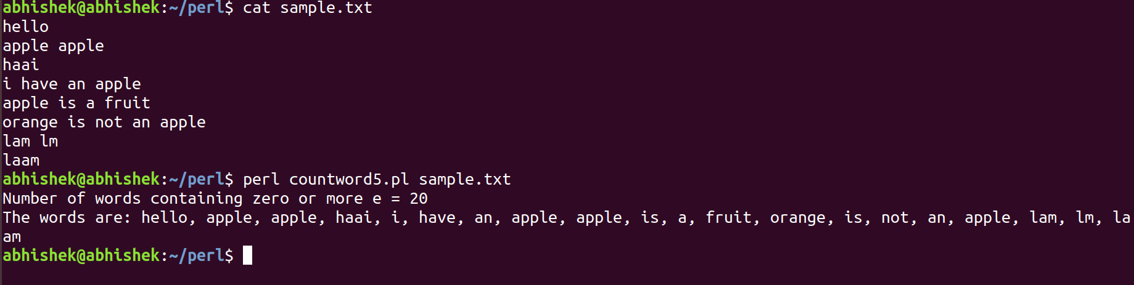

f) Search for words containing one or more occurrence of ‘e’

Script

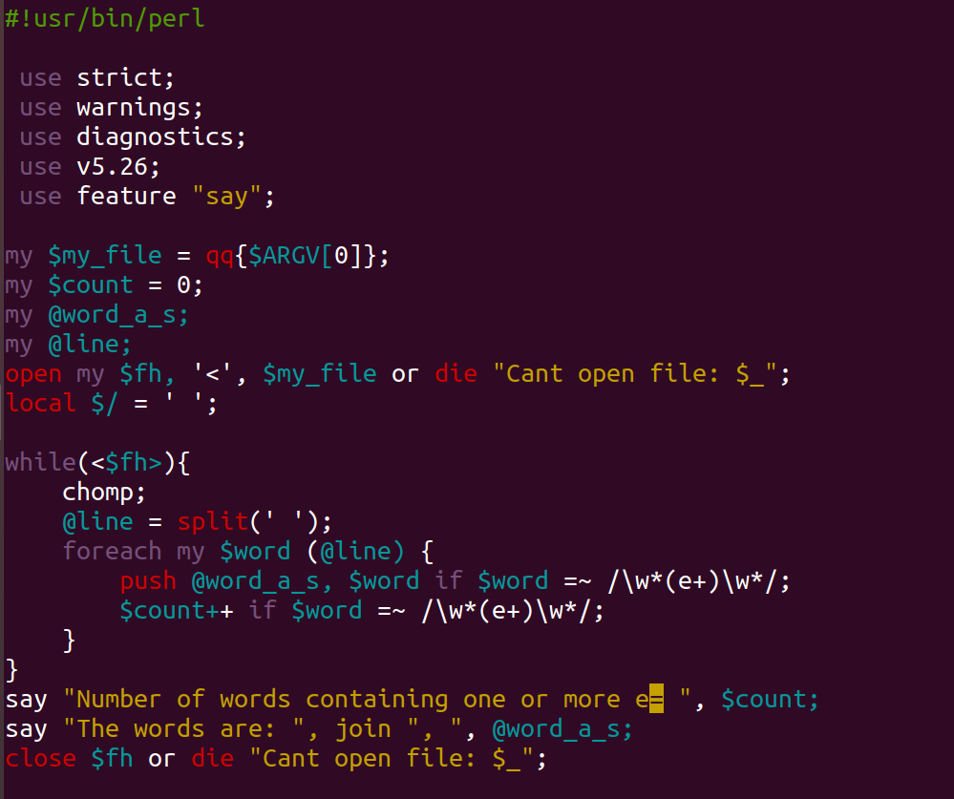
Output

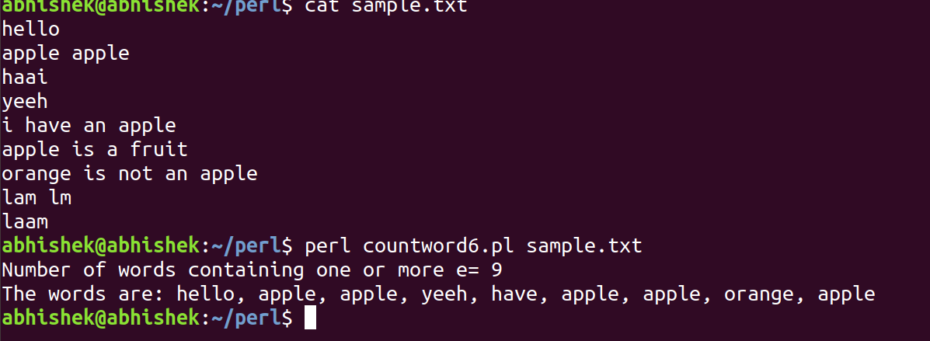
g) Search for words containing the letters ‘l’ and ‘m’, with any number of characters in between

Script
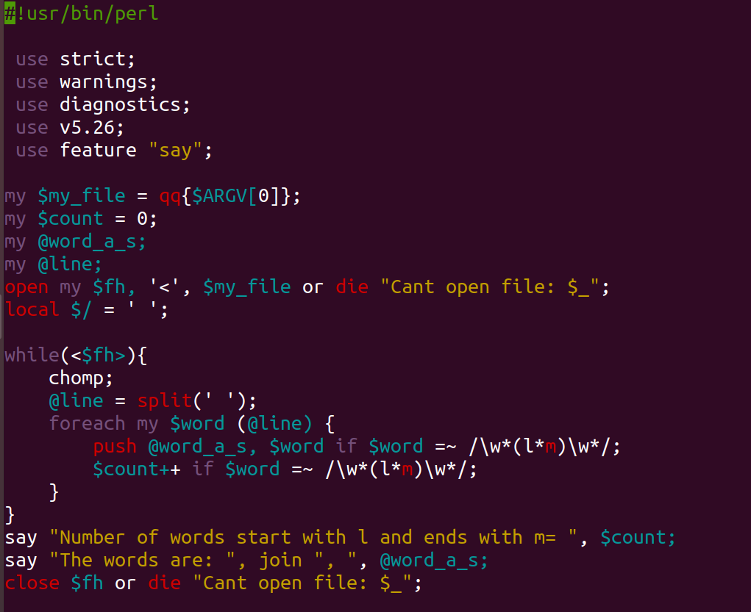
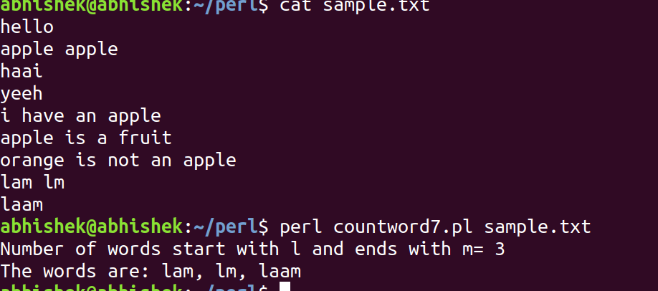
Output

Awk Scripting

1. Write a awk script that accepts date argument in the form of mm-dd-yy and displays it in the following format. The script should check the validity of the argument and in the case of error, display a suitable message.

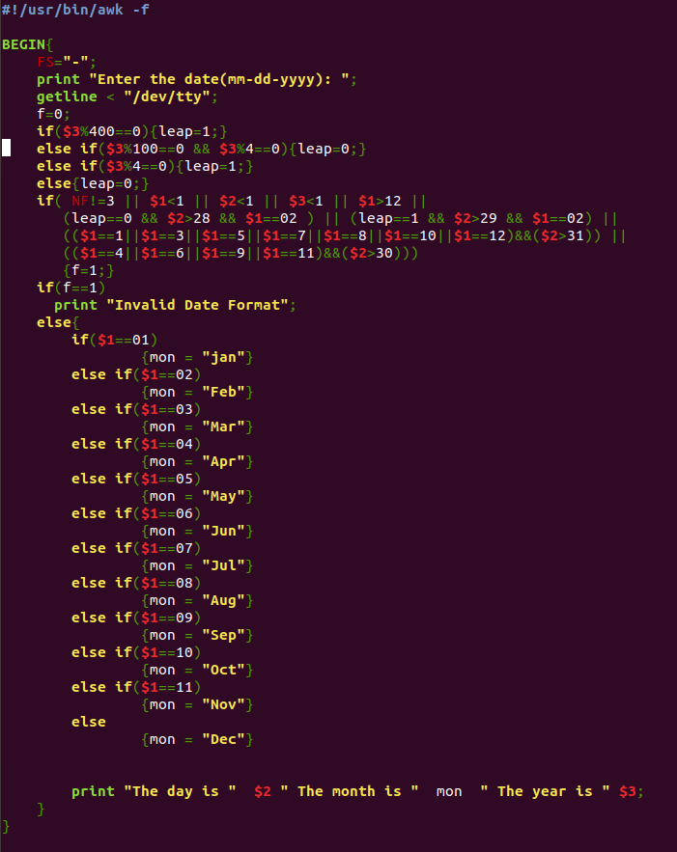
Script

Output

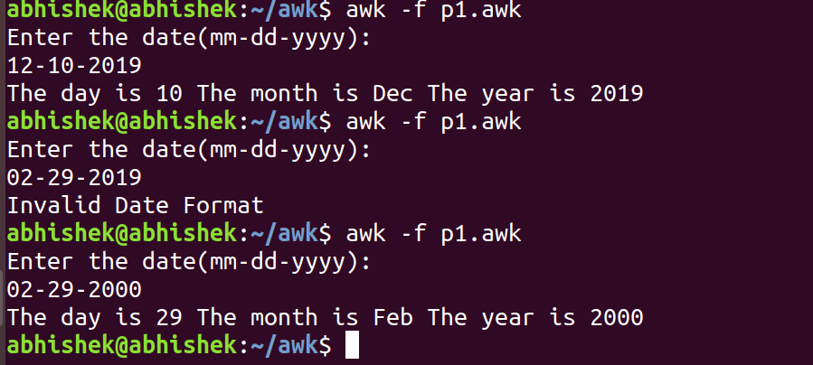

2) Write an awk script to delete duplicated line from a text file. The order of the original lines must remain unchanged

Script

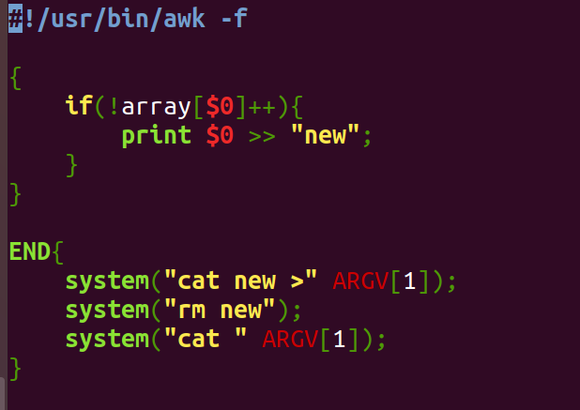

Output

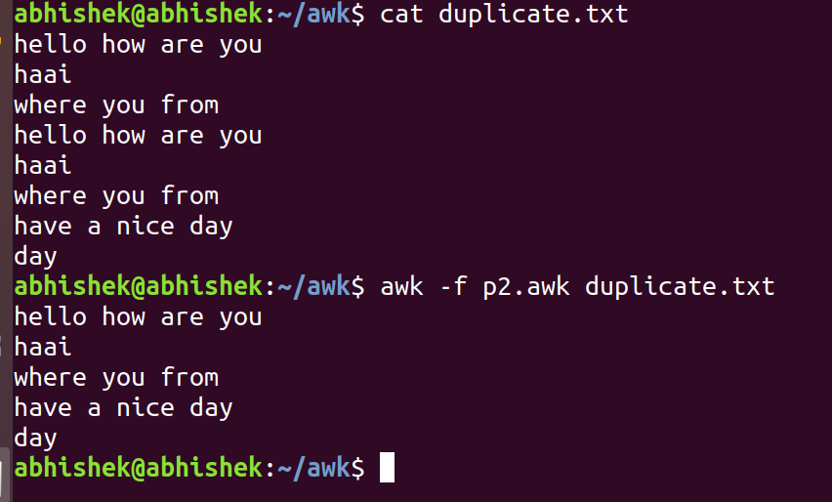

3) Write an awk script to find out total number of books sold in each discipline as well as total book sold based on the given table

electrical 34
mechanical 67
electrical 80
computers 43
mechanical 65
civil 198
computers 64

Script

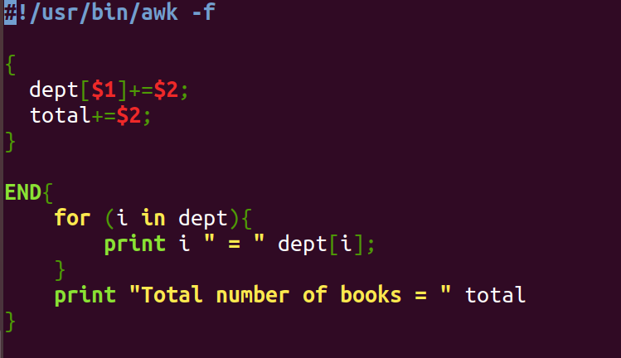
Output
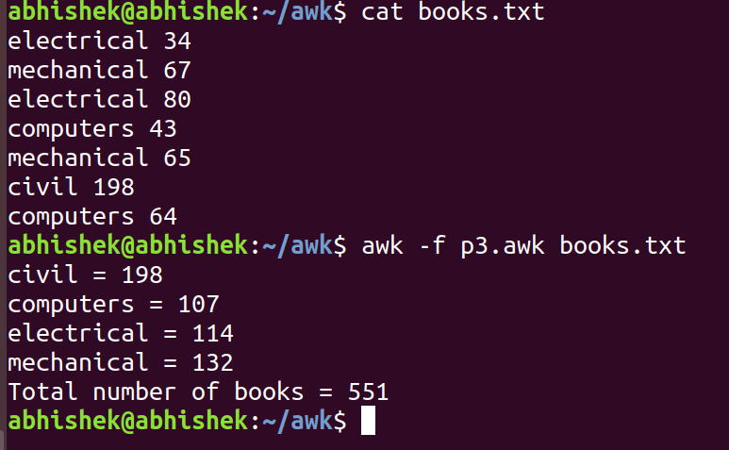
4) Write an awk script to compute gross salary of an employee accordingly to rule given below : If basic salary < 10000 then DA = 45% of the basic and HRA =15% of basic If basic salary >= 10000 then DA =50% of the basic and HRA =20% of basic.

Script
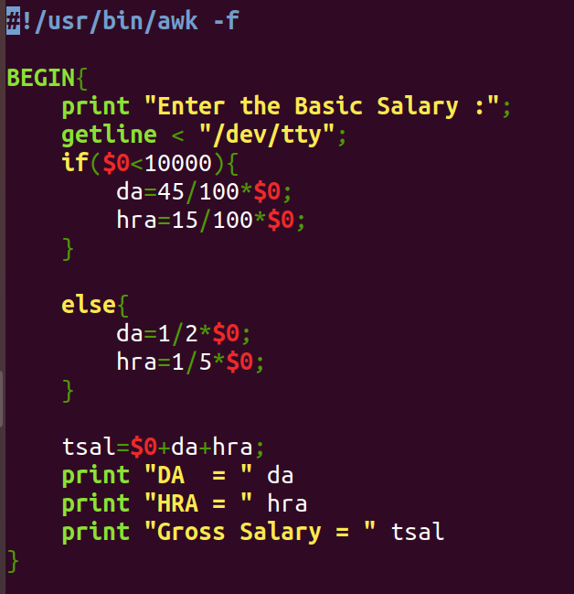

Output

